Dance Registration System

User Manual

Group Number: 2

CPSC 488 Section 01

Requirements

* MySQL Workbench v8.0.34 (https://dev.mysql.com/downloads/workbench/)
* Eclipse IDE for Enterprise Java and Web Developers v2023-09 R (https://eclipse.org/downloads)

User Instructions

Homepage

1. Upon running the localhost:8080, the user will see the home/login page
2. New users will select “Register” in the top right corner
3. Existing users who know their email & password will select “Login” in top right corner
4. Users may select the “Contact Us” button to view information about the dance company

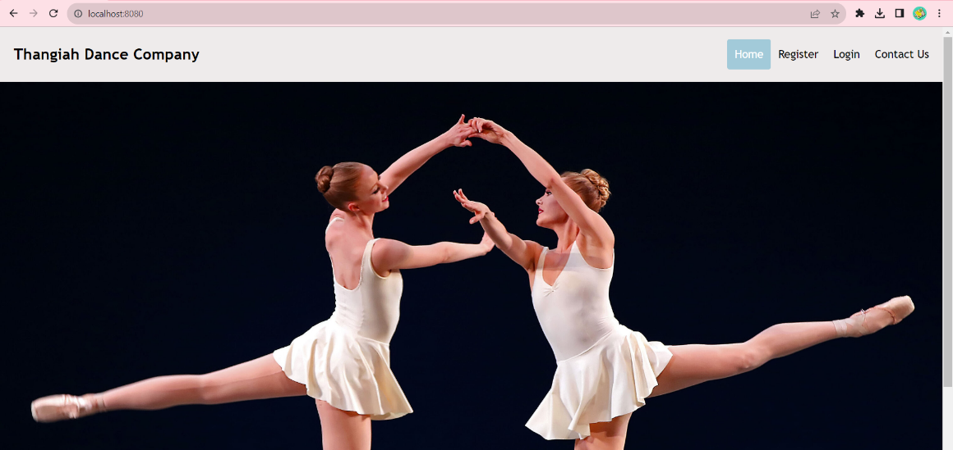

1. Register:
   * 1. The user must fill out the requested information.

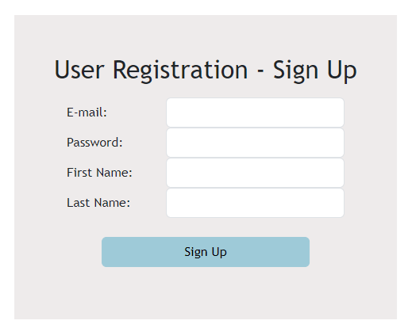

1. Login:

1. A screenshot of a login form

   Description automatically generatedIf the users’ credentials are incorrect, the cells will clear and provide the below message:
2. Upon first logon, every user will have to change their password

Admin Logon

* + - 1. Upon running the Eclipse project, an admin user is automatically generated with the below credentials:
         1. Email: admin@studio.com
         2. Password: root
      2. Navigate to the localhost:8080 and login with above credentials
      3. Once logged in, the admin user will be able to view the Admin Dashboard and have the below options to navigate to:
         1. Upload Admin File
         2. Export Admin file
         3. Create New User
         4. View Class Schedule
         5. Backup Database
         6. View Account Details
      4. Admin can toggle with viewing users from admins, managers, instructors, and parents

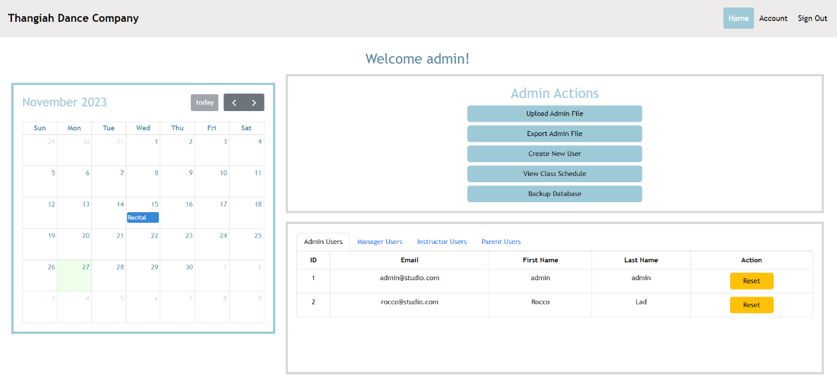

* + - 1. Admins can upload the Admin file (“AdminManagerLocation.xlsx”) by selecting the option under “Admin Actions”

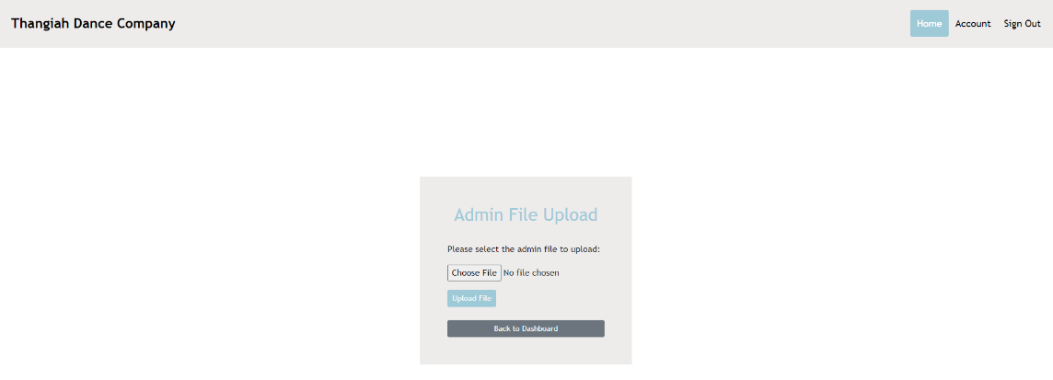

* + - 1. Admins can export the data they upload by selecting “Export Admin File”

* + - 1. Admins can create new Admin or Manager users

* + - 1. Admins can view the schedule for each location, toggling between the tabs:

* + - 1. Selecting “Account” in the top right will allow the user, in this case Admin, to view their account information

Manager Logon

1. Managers can only log in after Admin uploads the Admin file
2. Manager credentials:
   1. User’s email (i.e. ejs1027@studio.com)
   2. Default Password: 1234
3. Once a manager has logged in, they have the following options to:
   1. Upload/Export Files
   2. View Schedules and Class Lists
   3. Make Parent Payments + Check Balances
   4. Create New Instructors/Parents/Children
   5. View/Delete/Deactivate Instructors/Parents/Children

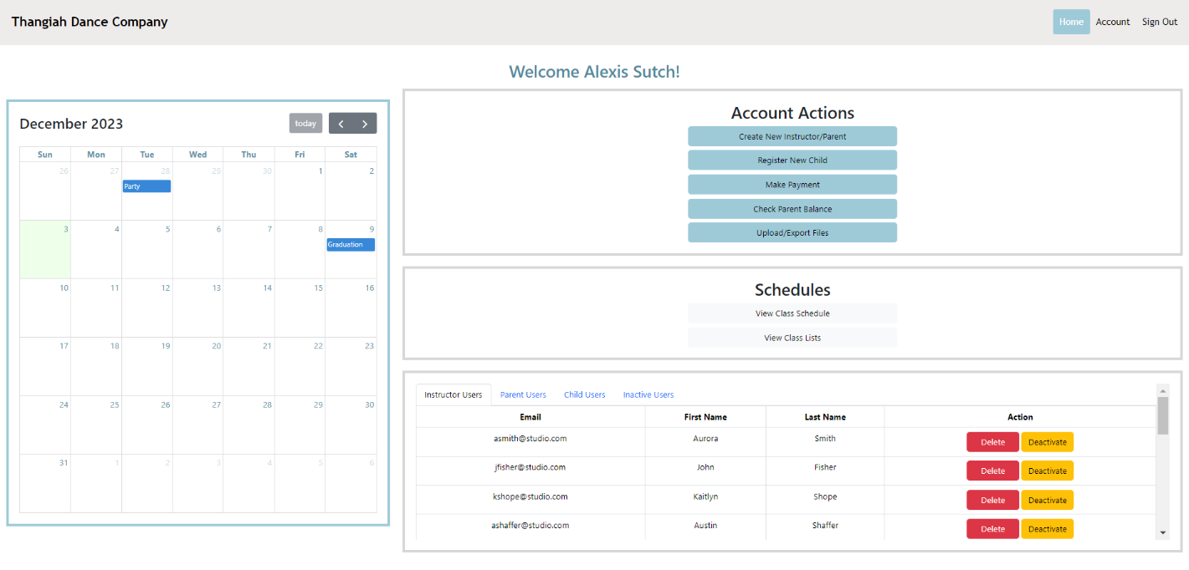

1. When selecting one of the four upload file options, managers will see respective displays

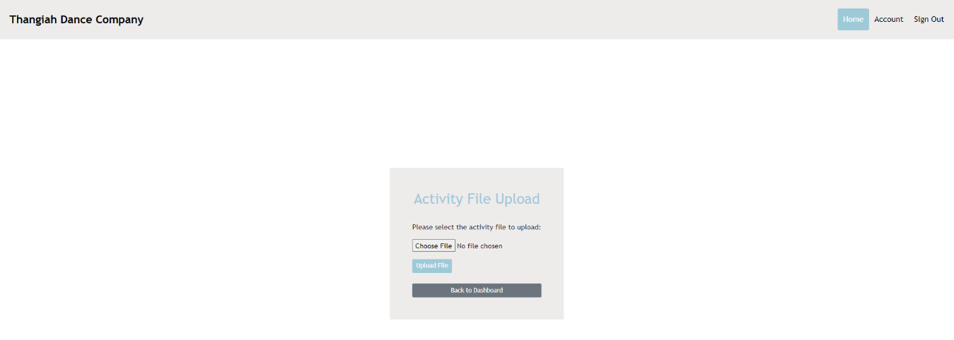

1. Deactivating users will move them to the “Inactive Users” tab on the Manager homepage
   1. Deleting a user will remove them entirely from the system
   2. Inactive users will stay in the system, but will not be able to log into their account
   3. Managers can reactivate the user at any time by clicking the “Activate” button

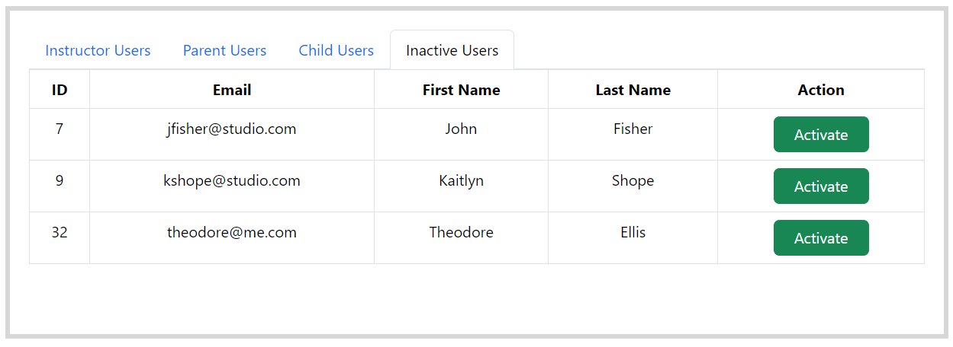

1. Managers can select to create a new user. The “Select Role” allows them to toggle between Instructor and Parent.

1. Managers can register new Children
   1. After entering the birthdate, the age will be auto-calculated
   2. The grade and parent can be selected from the provided dropdown lists

1. Managers have the option to view the Class Lists, which detail every child enrolled in each class and their respective studio
   1. Managers can remove children from individual classes
   2. Managers can also assign students to classes

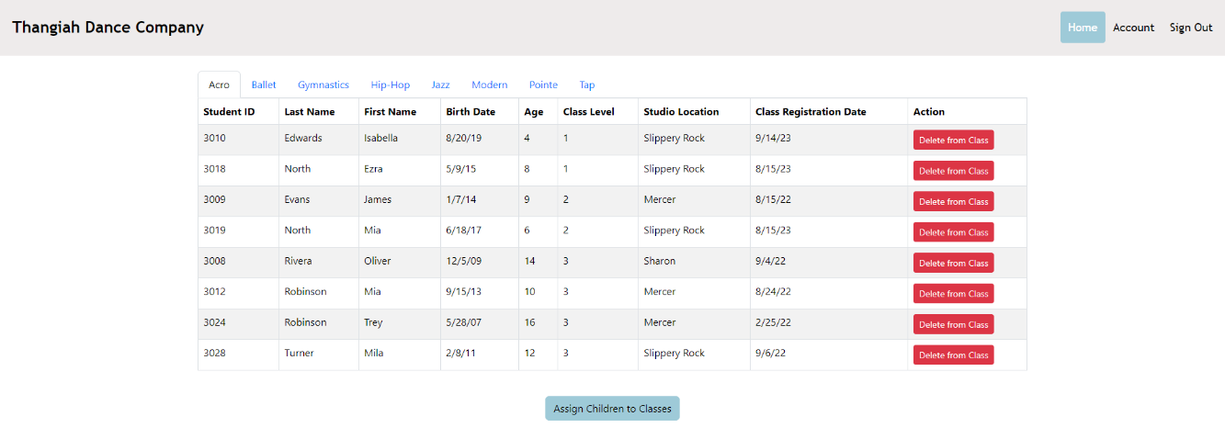

1. Managers can view parent’s account balance and make payments on their account

1. Managers can view the studio schedule and have the option to:
   1. Delete Activities
   2. Edit Start/End Time and Weekday of Activities

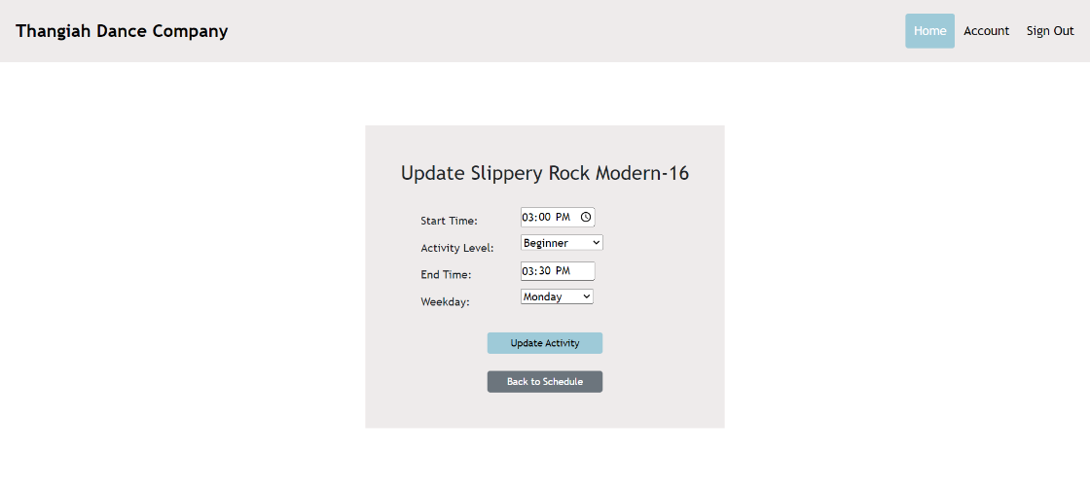

Parent Logon

1. The Parent dashboard allows the Parent to:
   1. View the company’s schedule for all locations
   2. View the activities that their child is enrolled in
   3. Make payments on their account
   4. View their transaction history
      1. In the below screenshot, Daphne has an outstanding balance of $130.00. If the account is overpaid/paid in advance – the balance will show as a negative value. This would be credit on the account.
         1. Daphne Turner Credentials:

Email: daphne@gmail.com

Default password: 1234

1. A screenshot of a computer

   Description automatically generatedView Class Schedule:
2. View Child’s Activities
   1. The dropdown will show all of the Parent users’ childrenA screenshot of a computer

      Description automatically generated

1. Make Payment
   1. Future Work:

Instructor Logon

1. The Instructor can:
   1. View the company’s schedules
   2. View the class rosters
   3. View their specific classes
   4. Example Instructor Credentials:
      1. Email: [sbanks@studio.com](mailto:sbanks@studio.com)
      2. Default Password: 1234

1. View the Schedules:

1. View the Class Lists

